UNIVERSITY OF RAJSHAHI
Department of Computer Science & Engineering
HallMenuRU
A Real-Time Cross-Platform Mobile Application for
Residential Hall Dining and Canteen Management

Submitted By
Maisha Binta Touhid (Student ID: 2312076106)
Tushar Ahmed Riyad (Student ID: 2311176139)
Shahriar Mahammud Himel (Student ID: 2310676104)
Session: 2022-23

Submitted To
A. F. M. Mahbubur Rahman
Associate Professor
Department of Computer Science & Engineering, University of Rajshahi
Date of Submission: 2026-07-08

Table of Contents
Table of Contents 2
Executive Summary 4
1. Introduction 5
2. Problem Statement 5
3. Project Objectives 6
4. Scope of the Project 6
5. System Overview and Overall Architecture 7
6. Technology Stack 9
7. Database Design 10
8. Repository Layer (Data-Access Design) 13
9. How the Frontend and Backend Communicate 14
10. Navigation and Screen Flow 17
11. Screen Description — Student Side 18
11.1 Splash Screen 18
11.2 Onboarding Screen 18
11.3 Home Screen 18
11.4 Hall List Screen 19
11.5 Hall Details Screen 19
11.6 Food Detail Screen 19
11.7 Global Food Search Screen 20
11.8 Notices Screen 20
11.9 Feast Screen 20
12. Screen Description — Moderator Side 21
12.1 Moderator Role Screen 21
12.2 Moderator Login Screen 21
12.3 Moderator Dashboard Screen 21
12.4 Menu Editor Screen (Dining) 22
12.5 Canteen Menu Editor Screen 22
12.6 Quick Status Screen (Dining) 22
12.7 Canteen Quick Status Screen 23
12.8 Available Food Screen (Serve and Restock) 23
12.9 Notice Editor Screen 24
12.10 Edit Notice Screen (List Mode) 24
12.11 Feast Editor Screen 24
12.12 Edit Feast Screen (List Mode) 25
12.13 Daily Reset Screen 25
12.14 Success Screen 25
13. Security Considerations 26
14. Challenges Faced and Solutions 26
15. Testing and Evaluation 28
16. Build and Deployment 29
17. Team Contribution 29
17.1 Member 1: Maisha Touhid — Lead Developer 29
17.2 Member 2: Tushar Ahmed Riyad— Documentation & Testing 29
17.3 Member 3: Shahriar Himel— Presentation & Design Support 30
18. Future Enhancements 30
19. Conclusion 30
20. References and Appendix 30

Executive Summary
HallMenu RU is a cross-platform mobile application, built with React Native and Expo, designed to digitise and streamline the dining and canteen information system across the seventeen residential halls of the University of Rajshahi. The application addresses a problem faced daily by thousands of students: the absence of any reliable way to check, before visiting the dining hall, what food is being served, whether a particular item is still available, or whether an important notice or upcoming feast has been announced.

The system is built around two distinct user roles. Students can browse all seventeen halls without requiring an account, view real-time dining and canteen menus organised by meal type, search for a specific food item across every hall simultaneously through a global search feature, rate and review individual food items, and stay informed through live notices and upcoming feast listings. Moderators — the dining and canteen staff responsible for each hall — authenticate securely and are equipped with a complete management dashboard: publishing daily menus, updating live item counts in real time, posting and editing notices and feasts, duplicating the previous day's menu as a starting point, and reviewing a full history of past updates.

The application's feature set reflects a deliberately complete design: a global food search across all halls, live auto-refreshing menus on the student side via real-time listeners, paired Serve and Restock controls for accurate live-count management, full list-based editing for notices and feasts, and enforced Firestore Security Rules governing read/write access. The project is also fully configured for production deployment, with Android APK builds generated through Expo Application Services (EAS Build).

The entire backend is powered by Firebase, Google's Backend-as-a-Service (BaaS) platform. Firebase Authentication handles secure email/password login for moderators, while Cloud Firestore — a NoSQL document database — stores all application data across five well-defined collections: menus, moderators, notices, feasts and foodReviews. All Firebase interactions are centralised within a single data-access module (repository.js) following the Repository Pattern, ensuring the user-interface layer remains fully decoupled from the underlying data storage and retrieval logic — a deliberate architectural choice that improves maintainability and testability.

This document presents the complete system architecture, database design, and screen-by-screen functionality for both user roles; the communication flow between frontend and backend; the key engineering decisions made during development along with their trade-offs; and the individual contribution of each team member.

1. Introduction
1.1 Background
The University of Rajshahi houses thousands of residential students across seventeen halls. Dining halls and canteens remain their primary food source, yet information flow between dining staff and students has stayed entirely manual — limited to notice boards, word of mouth, and physical visits to check what's being served.

1.2 Project Overview
HallMenu RU digitises this information cycle. It lets dining and canteen moderators publish and update menus in real time, while students access this information from their phones without any login. The name reflects its purpose — a menu management app for the halls of Rajshahi University (RU).

1.3 Motivation

The motivation came from observing daily inefficiencies in hall dining — students walking to the dining hall only to find their preferred item unavailable, or the menu not yet posted; moderators with no efficient channel for urgent updates like delays or shortages; and feast announcements frequently missed since students don't pass the notice board regularly. HallMenu RU is designed to remove this friction for both sides.

2. Problem Statement
The residential dining system at the University of Rajshahi faces the following documented, everyday challenges:
- No Remote Menu Access — students cannot see the day's dining menu without physically visiting the hall.
- No Real-Time Availability Information — when an item runs out mid-service, students who have not yet arrived have no way of knowing.
- Poor Notice Dissemination — delays, closures, and shortage announcements exist only on physical notice boards.
- No Centralised Feast Scheduling — feast dates, menus, and prices are communicated informally and inconsistently.
- Absence of a Feedback Mechanism — there is no structured channel for students to rate or comment on food quality.
- Manual, Repetitive Moderator Workload — each day's menu must be re-created from scratch with no digital duplication tool.
- No Historical Record — there is no system to review what was served on a given day or to hold anyone accountable for updates.
These issues collectively reduce student satisfaction, increase food wastage (because demand signals never reach the kitchen), and create repeated, avoidable administrative effort for moderators.

3. Project Objectives

3.1 Primary Objectives
- To develop a cross-platform mobile application that gives students real-time access to dining and canteen menus for all seventeen residential halls.
- To implement a secure, role-based moderator system so that designated dining and canteen staff can publish and update menus, availability status, notices, and feasts.
- To build a live food-availability tracking system where moderators adjust item counts as food is served or restocked, with automatic status transitions (available / limited / finished).
- To provide a structured notice system with configurable expiry so that only currently relevant notices are shown to students.
- To implement a food review and star-rating system so students can give quality feedback on individual food items.
- To allow students to search for a specific food item across all seventeen halls from a single screen, instead of opening each hall individually.

3.2 Secondary Objectives
- To implement timezone-correct date handling so menus and date keys are always accurate in the Asia/Dhaka timezone.
- To provide a Daily Reset mechanism allowing moderators to duplicate yesterday's menu or clear today's menu, reducing repetitive data entry.
- To implement moderator session persistence with password re-confirmation, avoiding repeated full logins without compromising security.
- To make the student-side menu view refresh automatically in real time whenever a moderator publishes a change, without a manual pull-to-refresh.
- To allow moderators to review and edit any previously posted notice or feast, not only the single most recent one.

4. Scope of the Project

4.1 In Scope
- Splash screen, onboarding slides, and role-selection home screen.
- Student-side browsing of all 17 halls with search and Boys/Girls filtering.
- Real-time (auto-refreshing) display of dining menus (breakfast, lunch, dinner) and canteen items per hall, per day.
- A Global Food Search screen allowing students to search for a food item by name across all 17 halls at once.
- Food item detail screen with star rating, written comment submission, and live display of all reviews.
- Notice board with accordion display, notice-type categorisation, and automatic expiry logic.
- Feast schedule display, filtered to show only today's and upcoming feasts.
- Moderator authentication with email/password login through Firebase Authentication, including session persistence with password re-confirmation.
- Moderator dashboard for dining and canteen roles, each with its own set of tools.
- Full menu editor for dining (breakfast, lunch, dinner) with item name, price, count, and status.
- Quick Status screens for rapid, bulk, per-item availability changes.
- Available Food screen with a live Serve (−1) control and a Restock (+1) control, with automatic status transitions.
- Notice posting, and list-mode notice editing that lets a moderator choose which of the hall's existing notices to edit or delete.
- Feast creation, and list-mode feast editing with the same browse-and-select behaviour.
- Daily Reset functionality — duplicate yesterday's menu or clear all items for today.
- Verification screen showing the full update-history log.
- Published Firestore Security Rules and an Android APK build pipeline through EAS Build.

4.2 Out of Scope
- Push notifications to student devices upon menu updates.
- Online payment or pre-ordering of meals.
- A university-wide administrative panel showing all 17 halls simultaneously.
- Student account creation or personalised student preferences.
- Integration with the university's ERP or student information systems.

5. System Overview and Overall Architecture

5.1 Architecture Style
HallMenu RU does not use a traditional client–server architecture with a custom application server. Instead, it follows a Backend-as-a-Service (BaaS) architecture, in which Firebase itself provides the server, the database, and the authentication system as fully managed cloud services. The mobile application communicates directly with Firebase using its official JavaScript SDK; there is no intermediate API layer written by the team.
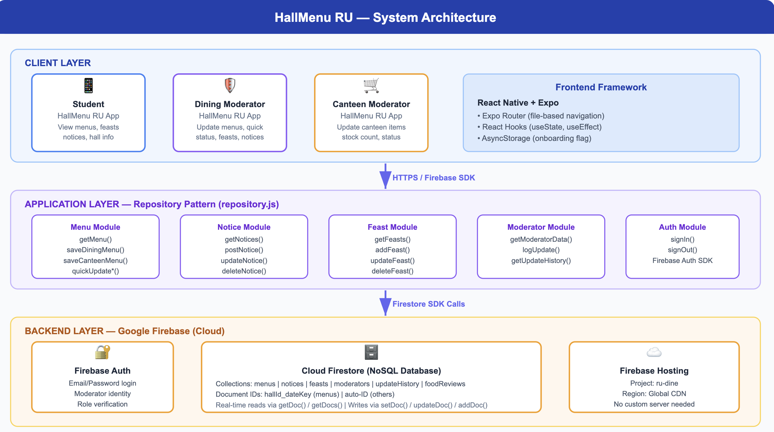This architecture was chosen deliberately for an academic project of this scale: it removes the operational burden of provisioning, securing, and scaling a custom server, while Firebase still provides production-grade authentication, a real-time database, and configurable authorisation rules out of the box.

5.2 Frontend Architecture
The frontend follows a three-layer structure that keeps the user interface, business logic, and data access clearly separated:
Layer | Location | Responsibility
Route Layer | src/app/ | Expo Router file-based routes. Each file is a thin wrapper that simply renders the matching Screen component — it contains no logic of its own.
Screen Layer | src/screens/ | The actual UI, state (useState/useEffect), validation, and calls into the data layer. Almost all application logic lives here.
Data Layer | src/data/ | Firebase initialisation, the Repository Pattern (repository.js), timezone-safe date utilities, static hall data, and shared constants.

Because every screen calls the data layer instead of talking to Firebase directly, a change to how data is fetched or stored only ever needs to be made in one place — repository.js — rather than being repeated across dozens of screens.

5.3 Backend Architecture
There is no custom backend server, no Node.js/Express API, and no self-managed database server. Firebase Cloud performs the entire role of the backend:
Firebase Service | Responsibility
Firebase Authentication | Moderator login and logout, JWT session-token issuance and refresh, and password hashing.
Firebase Firestore | The NoSQL cloud database that stores every piece of application data across six collections.
Firestore Security Rules | Server-side authorisation — controlling who is allowed to read or write each collection.
Firebase JavaScript SDK | The library through which the React Native frontend communicates with all of the above.

5.4 Overall Data Flow Summary
At a high level, every feature in the application follows one of four data-flow patterns, each of which is explained in full in Chapter 11 ("Frontend–Backend Communication"): a one-time read when a screen first loads, a real-time subscription that keeps a screen updated automatically, a write operation triggered by a Save or Post action, and an authentication flow used only on the moderator side.

6. Technology Stack
Layer | Technology | Purpose
Mobile Framework | React Native | Cross-platform UI rendering for both Android and iOS from one codebase.
Development Platform | Expo (SDK) | Build tooling, over-the-air updates, and simplified native module access.
Navigation | Expo Router (file-based) | Declarative, file-system-based routing; route groups provide bottom-tab navigation for the student and moderator sides.
Backend (BaaS) | Firebase | Complete backend infrastructure — authentication, database, and authorisation — with no custom server.
Authentication | Firebase Authentication | Email/password login and JWT-based session management.
Database | Firebase Firestore | NoSQL cloud document database with built-in real-time synchronisation.
Language | JavaScript (ES2022) | Primary development language for the entire application.
State Management | React Hooks (useState, useEffect) | Local, per-screen state — no Redux or Context API required.
Date/Timezone Handling | Intl / toLocaleDateString | Guarantees Asia/Dhaka-correct date keys everywhere the app checks "today".
Build & Deployment | Expo Application Services (EAS Build) | Produces installable Android APK builds using a single command.

React Native was selected to maximise code reuse across Android and iOS. Firebase was chosen over a custom Node.js/Express backend because it removes server provisioning entirely, ships industry-standard JWT-based authentication, offers a free tier that comfortably covers a university-scale user base, and provides native real-time synchronisation through onSnapshot listeners — a feature that would otherwise require significant extra infrastructure (such as WebSockets) to replicate in a custom backend.

7. Database Design

7.1 Database Type
Firebase Firestore is used as a NoSQL document database. Data is organised into Collections, which hold Documents, which in turn hold JSON-like field data. Firestore also provides real-time listeners, compound queries, server-generated timestamps, and atomic transactions, all of which are used by the application.

7.2 Collections Overview
Collection | Document ID Pattern | Purpose
menus | hallId_dateKey (e.g. sher_e_bangla_2026-05-26) | The complete dining and canteen menu for one hall, for one day.
moderators | Firebase Auth UID (auto-generated) | Each moderator's hall assignment, role, and display name.
notices | Auto-generated ID | Every notice posted by a dining or canteen moderator.
feasts | Auto-generated ID | Every feast event scheduled by a dining or canteen moderator.
foodReviews | Auto-generated ID | Every student star rating and comment on a specific food item.

7.3 menus Collection — Field Schema
Field | Type | Description
hallId | String | Hall identifier, e.g. sher_e_bangla.
date | String | Date key in YYYY-MM-DD format.
dining | Object | Contains breakfast, lunch, and dinner sub-objects, each holding items (name, price, count, status), a time range, and an optional note.
canteen | Object | Contains a single items array with the same item shape as above.
diningUpdatedBy / canteenUpdatedBy | String | Name of the moderator who last saved the dining or canteen section.
diningUpdatedAt / canteenUpdatedAt | Timestamp | Firebase server timestamp of the last dining or canteen save.
createdAt / updatedAt | Timestamp | Server timestamps for when the document was first created and most recently modified.

7.4 moderators, notices, and feasts Collections
Collection | Key Fields | Notes
moderators | hallId, hallName, name, role (dining/canteen), email, createdAt | One document per moderator account, keyed by the Firebase Auth UID so authentication and profile data stay linked automatically.
notices | hallId, hallName, type, noticeType, title, message, expiresIn, moderatorName, createdAt | hallName is denormalised (duplicated) directly into the notice so the Notices screen never needs a second lookup to display the hall's name.
feasts | hallId, hallName, role, date, title, timeRange, menu (array), price, moderatorName, createdAt | date is stored as a plain YYYY-MM-DD string so upcoming feasts can be filtered with a simple string comparison against today's date key.

7.5 foodReviews Collections
Collection | Key Fields | Notes
foodReviews | hallId, dateKey, itemName, mealType, rating (1–5), comment, createdAt | Read with a compound query — filtering by hallId, dateKey, and itemName together, ordered by newest first — which is why this collection requires a manually created Firestore composite index (see Chapter 16).

7.6 Document ID Design Decision
The menus collection deliberately uses a composite document ID of hallId underscore dateKey instead of an auto-generated ID. This means the entire day's menu for a hall can be fetched with a single document read (an O(1) lookup) rather than a query that filters by hallId and date separately. The trade-off, documented honestly in Chapter 15 (Security Considerations), is that the document ID is predictable, which matters only if Security Rules are not in place — a gap this project has since closed by publishing Firestore Security Rules.

7.7 Denormalisation Strategy
Firestore has no JOIN operation, so fields such as hallName are deliberately duplicated (denormalised) into the notices and feasts documents. This avoids a second database read every time a notice or feast is displayed, at the acceptable cost of needing to update hallName in more than one place if a hall were ever renamed — an event that does not occur in practice for this application.

7.8 Collection Relationships
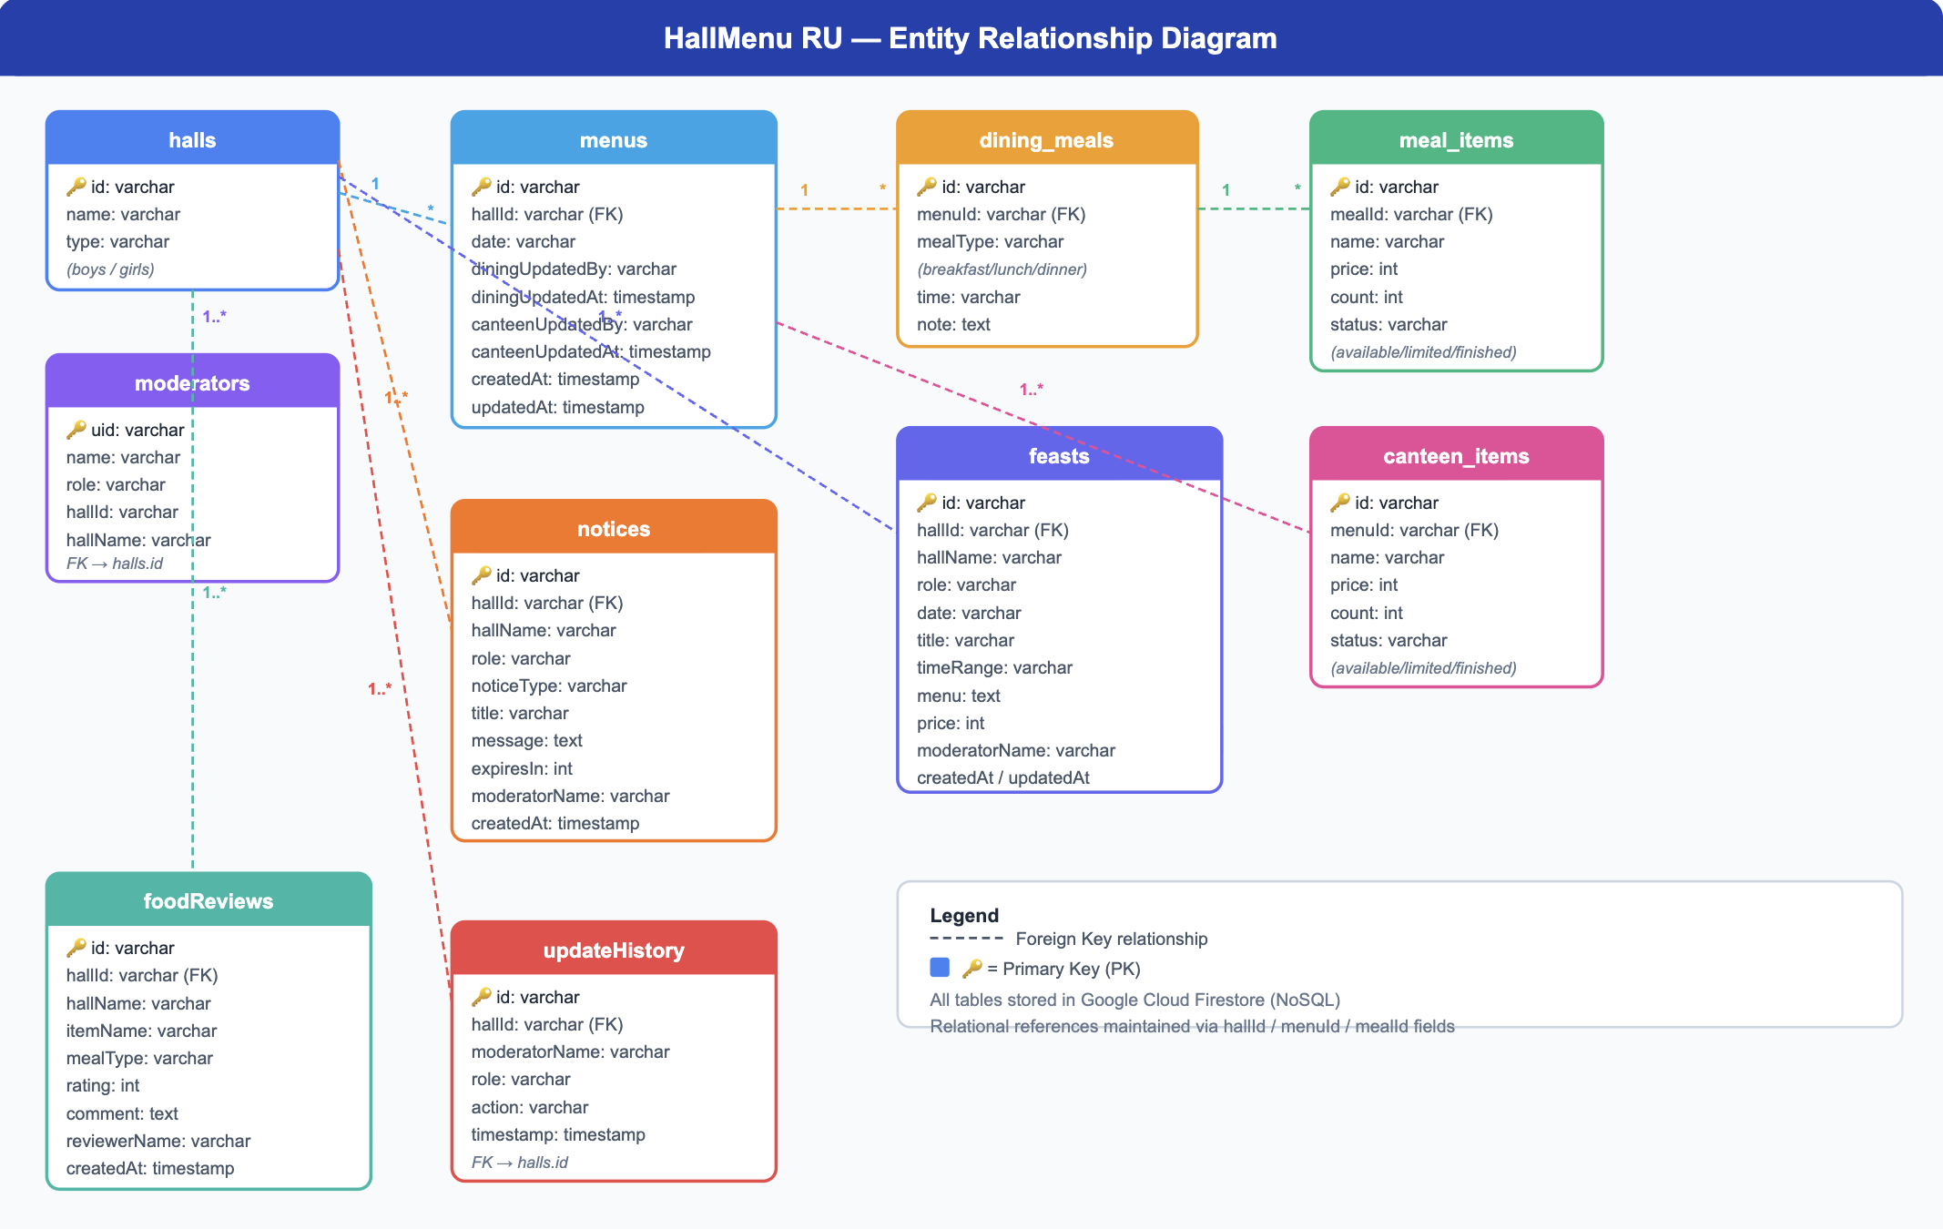

8. Repository Layer (Data-Access Design)
Every single interaction with Firestore in the entire application passes through one file, src/data/repository.js, following the Repository Pattern. No screen ever imports Firebase directly. This section explains, what each repository function is responsible for and why it exists .

8.1 Menu Functions
Function | Purpose
getMenu(hallId, dateKey) | Performs a single one-time document read to fetch a hall's complete menu for a given day. Returns null if that hall has not been updated yet that day.
subscribeMenu(hallId, dateKey, callback) | Opens a real-time listener on a hall's menu document. Whenever a moderator saves a change, Firestore automatically pushes the new data to every subscribed student screen — this is what powers the auto-refreshing student view.
upsertMenu(hallId, dateKey, payload) | The core "create-or-update" function. It checks whether the day's document already exists; if so it updates only the given fields, otherwise it creates the document with all required fields. Every other write function is built on top of this one.
saveDiningMenu / saveCanteenMenu | Wrap upsertMenu to save a full dining or canteen menu, and additionally record which moderator made the change and when.
quickUpdateDining / quickUpdateCanteen | Wrap upsertMenu for fast, bulk status/count changes from the Quick Status screens, without touching item names or prices.
duplicateYesterday(hallId, dateKey, type) | Reads yesterday's menu (using a timezone-safe "yesterday" key) and copies its dining or canteen section into today's document, giving moderators a starting point instead of retyping the whole menu.

8.2 Notice and Feast Functions
Function | Purpose
getNotices(type) | Fetches all notices for the dining or canteen side, then filters out any notice whose expiry window (createdAt + expiresIn hours) has already passed, so only currently active notices are ever shown.
postNotice / updateNotice / deleteNotice | Create, edit, or remove a single notice document.
getFeasts(type) | Fetches all feasts for the dining or canteen side, sorted by date, so the Feast screen can filter out anything before today.
addFeast / updateFeast / deleteFeast | Create, edit, or remove a single feast document.

8.3 Authentication, Moderator, and Audit Functions
Function | Purpose
signInWithEmailAndPassword / signOut | Firebase Authentication calls used to log a moderator in or out.
getModeratorData(uid) | Reads the moderators collection to retrieve a logged-in moderator's hall assignment, role, and display name.
logUpdate(hallId, moderatorName, role, action) | Writes one entry into updateHistory every time a moderator performs a significant save, building the audit trail shown on the Verification screen.
getUpdateHistory(hallId) | Reads the most recent update-history entries for a hall (capped at 50) for display on the Verification screen.

8.4 Why Centralise Everything in One File
- Code Reuse — the same Firebase call is never written twice across different screens.
- Maintainability — if Firebase's API changes, or the data shape changes, only repository.js needs to change.
- Testability — the repository can be mocked so screen behaviour can be tested independently of a live Firestore connection.
- Separation of Concerns — screens focus purely on what to show and how the user interacts with it; the repository focuses purely on how that data is stored and retrieved.

9. How the Frontend and Backend Communicate
HallMenu RU has no traditional REST API of its own; the Firebase JavaScript SDK plays that role. This chapter walks through the four ways a screen and Firestore exchange data.
9.1 One-Time Read Flow (e.g. opening the Hall List)
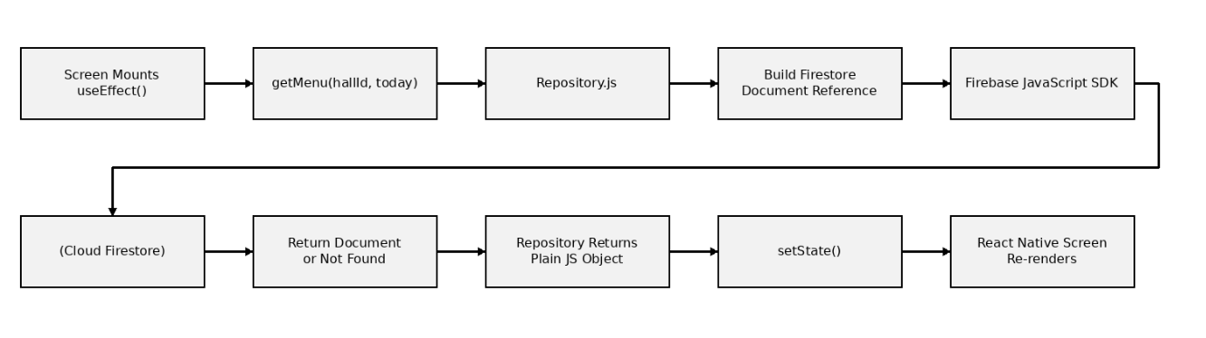

9.2 Real-Time Subscription Flow (Student menu view, food reviews)
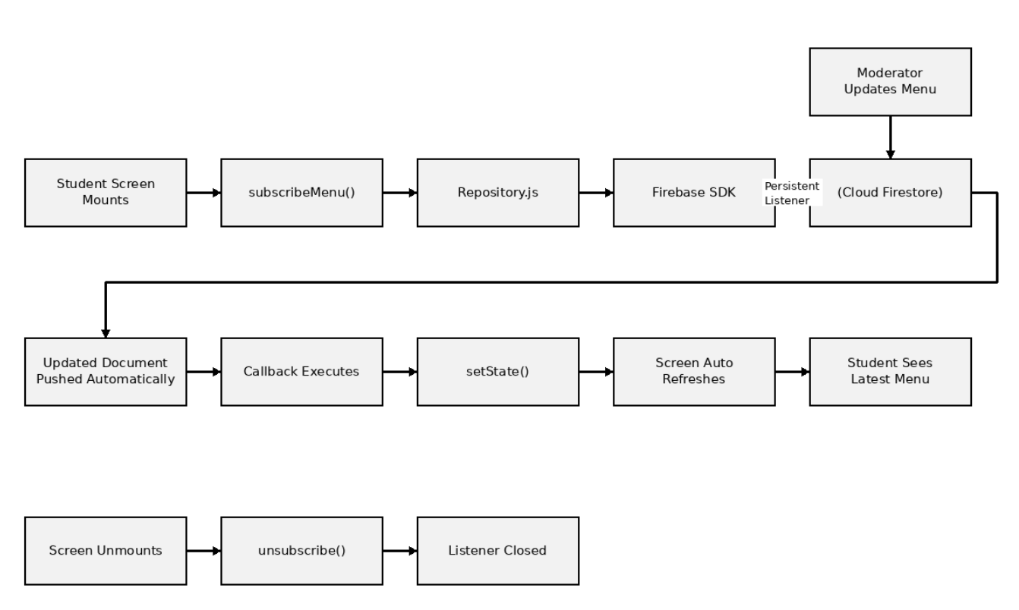 This is the exact mechanism that makes the student-side Hall Details screen "auto-refresh": rather than the student having to pull down to refresh, any change a moderator publishes appears on the student's phone automatically, because the screen is subscribed rather than performing a one-time fetch.
9.3 Write / Save Flow (Moderator publishing a menu, notice, or feast)
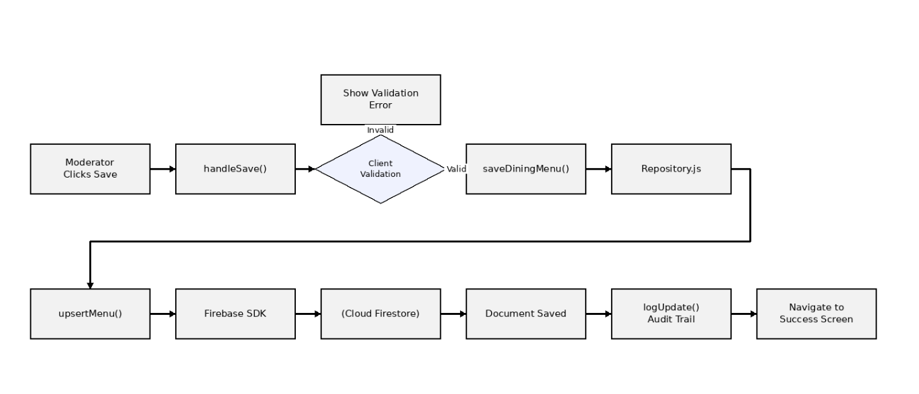
9.4 Authentication Flow (Moderator login)
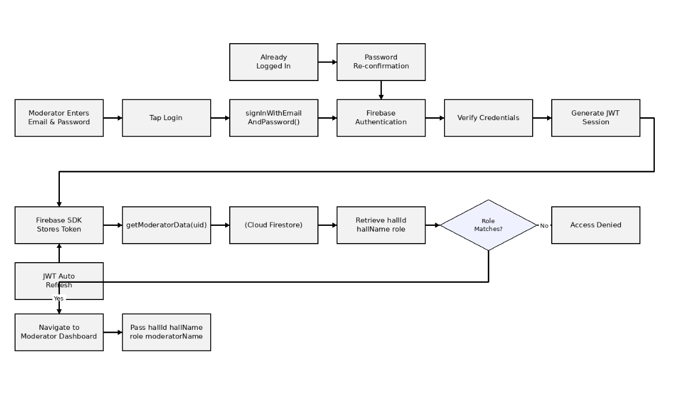 The JWT session token is refreshed automatically by the Firebase SDK roughly every hour, without any action needed from the application. When a moderator returns to the Moderator Role screen while already logged in, the app detects the existing session and shows a lightweight password re-confirmation modal instead of the full login form, improving usability without weakening security — re-authentication is still verified against Firebase, never compared locally.
Overall Frontend ↔ Backend Communication Architecture
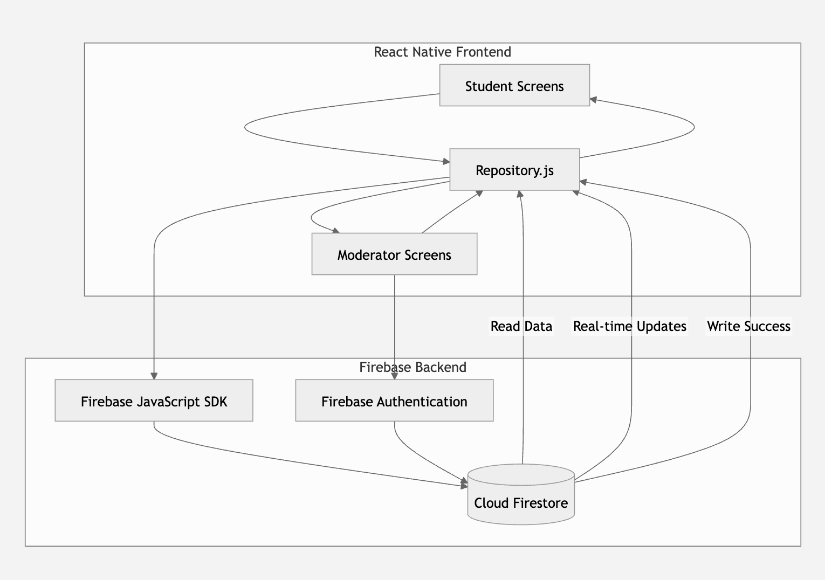

10. Navigation and Screen Flow
Navigation is implemented with Expo Router, which maps files inside src/app/ directly to routes. Screens for the student side and the moderator side are grouped under Expo Router's parenthesised route-group folders, which additionally gives each side its own bottom tab bar for the most frequently used screens, while every individual screen keeps the same name and file it already had.
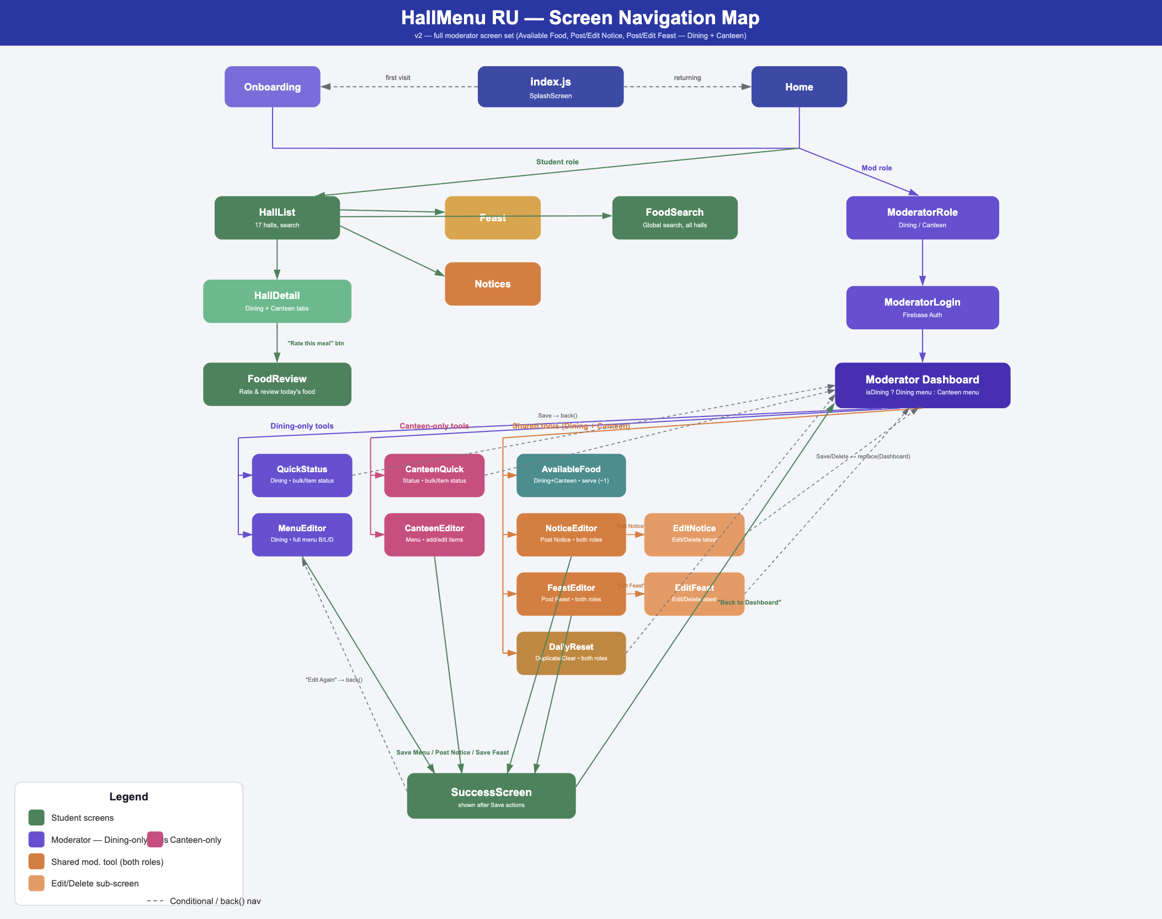router.push() is used for ordinary forward navigation, while router.replace() is used after a save or logout so that the navigation stack entry is replaced rather than stacked — for example, after a menu is saved, the Back button on the Success screen does not return the moderator to the editor with unsaved-looking state.

11. Screen Description — Student Side
No login is required for any screen in this section. All data shown to students is read-only from the student's perspective.

11.1 Splash Screen
Field | Description
Accessible To | All users (first screen on app open)
Purpose | Displays the app's brand identity — RU logo, app name, and tagline — for two seconds before automatically continuing to Onboarding.
Key Features & User Actions | Animated loading dots; no user input required; automatic timed navigation.
Data Source / Repository Functions Used | None (no Firebase call on this screen).
Navigation | Automatically navigates to Onboarding after 2 seconds.

11.2 Onboarding Screen
Field | Description
Accessible To | First-time users (skippable)
Purpose | Introduces the app across three slides explaining what the app does.
Key Features & User Actions | Next / Back / Skip / Get Started buttons; swiping between slides.
Navigation | Continues to Home when finished or skipped.

11.3 Home Screen
Field | Description
Accessible To | All users
Purpose | Lets the user choose whether they are using the app as a Student or as a Moderator.
Key Features & User Actions | Two role cards: Student and Moderator.
Data Source / Repository Functions Used | None.
Navigation | Student -> Hall List. Moderator -> Moderator Role screen.

11.4 Hall List Screen
Field | Description
Accessible To | Student
Purpose | Shows all 17 halls with a search box, a Boys/Girls/All filter, and an "Updated today" badge indicating which halls already have a menu published for the current date.
Key Features & User Actions | Type in the search box; tap a filter chip; tap a hall card; tap the Feast or Notice quick-link cards.
Data Source / Repository Functions Used | getMenu() is called once per hall (17 parallel reads) purely to determine the "Updated today" badge; the hall list itself comes from a static local list (halls.js).
Navigation | Tapping a hall opens Hall Details. Quick links open Feast or Notices.

11.5 Hall Details Screen
Field | Description
Accessible To | Student
Purpose | Shows one hall's complete Dining (breakfast/lunch/dinner) and Canteen menu for today, and now refreshes automatically the moment a moderator publishes a change.
Key Features & User Actions | Expand Dining or Canteen section; switch between breakfast/lunch/dinner tabs; tap any food item.
Data Source / Repository Functions Used | subscribeMenu(hallId, today) — a real-time onSnapshot listener, replacing the previous one-time getMenu() fetch, so the screen updates live without a manual refresh.
Navigation | Tapping a food item opens Food Detail for that item.

11.6 Food Detail Screen
Field | Description
Accessible To | Student
Purpose | Shows full details of one food item, its live remaining count, its average rating, and lets the student submit a star rating and written review.
Key Features & User Actions | Select 1–5 stars; type a comment; tap Submit Review; scroll through all existing reviews.
Data Source / Repository Functions Used | onSnapshot on the foodReviews collection (filtered by hall, date, and item name) for real-time reviews; addDoc() to submit a new review.
Navigation | Reached from Hall Details or from the Global Food Search screen; Back returns to whichever screen it was opened from.

11.7 Global Food Search Screen
Field | Description
Accessible To | Student
Purpose | Lets a student search for a specific food item by name across all 17 halls at once, instead of having to open each hall individually to check.
Key Features & User Actions | Type a food name; results update instantly as the student types; tap a result to view its Food Detail.
Data Source / Repository Functions Used | A one-time parallel fetch of today's menu across all 17 halls (mirroring the same fan-out pattern already used for the "Updated today" badge on Hall List), followed by client-side filtering as the student types — no extra Firestore read is made per keystroke.
Navigation | Reached from Hall List; tapping a result opens Food Detail.

11.8 Notices Screen
Field | Description
Accessible To | Student
Purpose | Shows all currently active Dining and Canteen notices, grouped into two expandable sections, with expired notices automatically hidden.
Key Features & User Actions | Expand/collapse the Dining or Canteen section.
Data Source / Repository Functions Used | getNotices('dining') and getNotices('canteen'), each of which filters out any notice whose expiry window has passed.
Navigation | Reached from the Hall List quick link; Back returns to Hall List.

11.9 Feast Screen
Field | Description
Accessible To | Student
Purpose | Shows upcoming and today's Dining and Canteen feasts, grouped into two expandable sections, with past feasts automatically hidden.
Key Features & User Actions | Expand/collapse the Dining or Canteen section.
Data Source / Repository Functions Used | getFeasts('dining') and getFeasts('canteen'), filtered locally to keep only feasts dated today or later.
Navigation | Reached from the Hall List quick link; Back returns to Hall List.

12. Screen Description — Moderator Side
Every screen in this section requires a moderator to be logged in, except the role-selection and login screens themselves. A moderator only ever sees and edits their own hall's data — dining moderators manage dining content, canteen moderators manage canteen content.

12.1 Moderator Role Screen
Field | Description
Accessible To | Moderator (pre-login)
Purpose | Lets the user choose Dining Moderator or Canteen Moderator. If a session already exists for the chosen role, a password re-confirmation modal is shown instead of the full login form.
Key Features & User Actions | Tap Dining or Canteen; if already logged in, re-enter password to confirm identity.
Data Source / Repository Functions Used | auth.currentUser check; getModeratorData(uid); signInWithEmailAndPassword() for re-confirmation.
Navigation | New session -> Moderator Login. Existing session confirmed -> Moderator Dashboard directly.

12.2 Moderator Login Screen
Field | Description
Accessible To | Moderator (pre-login)
Purpose | Standard email/password login screen, with the role locked to whichever was selected on the previous screen.
Key Features & User Actions | Enter email or username and password; toggle password visibility; tap Login.
Data Source / Repository Functions Used | signInWithEmailAndPassword(); getModeratorData(uid); role-mismatch is checked before proceeding.
Navigation | On success -> Moderator Dashboard, with hallId/hallName/role/moderatorName passed as navigation params.

12.3 Moderator Dashboard Screen
Field | Description
Accessible To | Moderator (dining or canteen)
Purpose | The control-panel entry point to every moderator feature, with a distinct set of menu tiles depending on whether the moderator is dining or canteen.
Key Features & User Actions | Tap any feature tile; tap Logout.
Data Source / Repository Functions Used | No direct Firebase read on this screen — it renders purely from the navigation params it received at login.
Navigation | Each tile navigates to its corresponding feature screen, passing hallId/hallName/role/moderatorName forward.

12.4 Menu Editor Screen (Dining)
Field | Description
Accessible To | Dining Moderator
Purpose | Creates or edits the full breakfast, lunch, and dinner menu for today, including item name, price, count, and status for each item, plus a per-meal time range and note.
Key Features & User Actions | Switch meal tabs; add/remove items; edit name/price/count; set status; preview before saving; Save Menu.
Data Source / Repository Functions Used | getMenu() to load any existing menu; saveDiningMenu() to save; logUpdate() to record the audit entry.
Navigation | Preview -> Success screen on confirm. Success -> back to Dashboard.

12.5 Canteen Menu Editor Screen
Field | Description
Accessible To | Canteen Moderator
Purpose | The canteen equivalent of the Menu Editor — creates or edits all canteen items with name, price, count, and status.
Key Features & User Actions | Add/remove items; edit fields; set status; preview; Save Canteen Menu.
Data Source / Repository Functions Used | getMenu() to load; saveCanteenMenu() to save; logUpdate() to record the audit entry.
Navigation | Preview -> Success screen on confirm. Success -> back to Dashboard.

12.6 Quick Status Screen (Dining)
Field | Description
Accessible To | Dining Moderator
Purpose | A fast alternative to the full Menu Editor for changing only the status (and count) of existing items, per meal, including a bulk "All Available / All Low / All Finished" action.
Key Features & User Actions | Tap a status chip per item; tap a bulk-action chip for an entire meal; Save Updates.
Data Source / Repository Functions Used | getMenu() to load current items; quickUpdateDining() to save.
Navigation | Save returns the moderator to the Dashboard.

12.7 Canteen Quick Status Screen
Field | Description
Accessible To | Canteen Moderator
Purpose | The canteen equivalent of Quick Status — rapid status and count updates for existing canteen items, with the same bulk-action shortcuts.
Key Features & User Actions | Edit count per item; tap a status chip; tap a bulk-action chip; Save Updates.
Data Source / Repository Functions Used | getMenu() to load; quickUpdateCanteen() to save.
Navigation | Save returns the moderator to the Dashboard.

12.8 Available Food Screen (Serve and Restock)
Field | Description
Accessible To | Dining or Canteen Moderator
Purpose | Shows every item with its live remaining count and lets the moderator adjust it in real time as food is actually served at the counter.
Key Features & User Actions | Serve (−1) button reduces the count by one and automatically flips status to "limited" at 10 or fewer remaining and "finished" at zero. A Restock (+1) button — a newly added control — increases the count back up, for correcting an accidental serve tap or adding a freshly prepared batch, without needing to reopen the Menu Editor.
Data Source / Repository Functions Used | getMenu() to load current counts; upsertMenu() to write the updated count and status back after each Serve or Restock tap.
Navigation | Reached from the Dashboard; Back returns to the Dashboard.

12.9 Notice Editor Screen
Field | Description
Accessible To | Dining or Canteen Moderator
Purpose | Posts a brand-new notice with a type, title, message, and an expiry window in hours.
Key Features & User Actions | Select notice type; enter title and message; set expiry hours; Post Notice.
Data Source / Repository Functions Used | postNotice().
Navigation | Save -> Success screen -> back to Dashboard.

12.10 Edit Notice Screen (List Mode)
Field | Description
Accessible To | Dining or Canteen Moderator
Purpose | Previously showed only the single most recently posted notice for editing. It now first lists every notice the hall has posted as individual cards; the moderator taps the one they want to open in the edit form to update or delete it.
Key Features & User Actions | Browse the list of the hall's notices; tap a card to edit it; change type/title/message/expiry; Save Changes or Delete.
Data Source / Repository Functions Used | getNotices(role) filtered to the current hall to build the list; updateNotice() and deleteNotice() for the selected item.
Navigation | Save or Delete returns to the Dashboard.

12.11 Feast Editor Screen
Field | Description
Accessible To | Dining or Canteen Moderator
Purpose | Schedules a new feast with a date, title, time range, menu items, and price.
Key Features & User Actions | Enter date/title/time range/menu/price; Save Feast.
Data Source / Repository Functions Used | addFeast().
Navigation | Save -> Success screen -> back to Dashboard.

12.12 Edit Feast Screen (List Mode)
Field | Description
Accessible To | Dining or Canteen Moderator
Purpose | Previously showed only the single most recently added feast for editing. It now first lists every feast the hall has scheduled as individual cards; the moderator taps the one they want to open in the edit form to update or delete it.
Key Features & User Actions | Browse the list of the hall's feasts; tap a card to edit it; change date/title/time range/menu/price; Save Changes or Delete.
Data Source / Repository Functions Used | getFeasts(role) filtered to the current hall to build the list; updateFeast() and deleteFeast() for the selected item.
Navigation | Save or Delete returns to the Dashboard.

12.13 Daily Reset Screen
Field | Description
Accessible To | Dining or Canteen Moderator
Purpose | Gives the moderator a quick starting point for the new day — either copy yesterday's menu forward, or clear today's menu completely.
Key Features & User Actions | Tap Duplicate Yesterday, or tap Clear Everything (with a confirmation prompt).
Data Source / Repository Functions Used | duplicateYesterday() (built on getMenu() and upsertMenu() internally); upsertMenu() directly for the Clear action.
Navigation | Both actions return to the Dashboard on completion.

12.14 Success Screen
Field | Description
Accessible To | Dining or Canteen Moderator
Purpose | A confirmation screen shown after any successful save, with the option to return to the Dashboard or edit the same content again.
Key Features & User Actions | Tap Back to Dashboard, or tap Edit Again.
Data Source / Repository Functions Used | None (purely a confirmation screen).
Navigation | Back to Dashboard -> Dashboard. Edit Again -> the screen just used, via router.back().

13. Security Considerations

13.1 Implemented Security Measures
Measure | Implementation
Firebase configuration | Stored only in environment variables, never hardcoded into source files.
Password storage | Handled entirely by Firebase Authentication using bcrypt hashing; the application never sees or stores a plain-text password.
Session tokens | JWT tokens issued and automatically refreshed by the Firebase SDK.
Role check on login | The moderator's stored role is compared against the selected role before the Dashboard is opened.
Input validation | Required-field checks, numeric validation, and .trim() are applied before every write.
Firestore Security Rules | Published rules restrict all writes to authenticated users, while read access to menus, notices, and feasts remains public for students, who use no login at all.
Re-authentication for sessions | The password-confirmation modal re-verifies the password against Firebase itself, never against a locally stored value.

13.2 Known Security Limitations
The team believes in documenting limitations honestly rather than hiding them. The following gaps are acknowledged:
- Fine-grained ownership rules — the published Security Rules validate that a write comes from an authenticated user, but do not yet validate that a given moderator is writing only to their own hall's documents at the rules level (this is currently enforced only in the client-side login role check).
- foodReviews has no authentication requirement at all — any client can submit a review, since students never log in by design.

14. Challenges Faced and Solutions
Building HallMenu RU was our first time taking an idea all the way from a rough sketch to a real, working app. Along the way, we ran into problems that weren't in any tutorial — the kind you only discover once you're actually building something for real users.
Development surfaced several genuine engineering problems in different parts of the system. Each is listed here by the area of the project it belongs to, together with the solution that was actually implemented, and — where the fix is still pending — the reason it remains a documented, open issue rather than a hidden one.
14.1 Starting with Design, Not Code
Challenge | Resolution
Before writing a single line of code, I had to figure out what the app should even look like — how many screens, what a student sees versus what a moderator sees, and how someone moves between them. As a beginner, my first instinct was to jump straight into coding, but that led to screens that didn't fit together well. | I eventually learned to sketch the full user flow first — student side and moderator side separately — before touching React Native. This saved a lot of rework later.
14.2 Choosing a Backend we'd Never Used Before
Challenge | Resolution
we had never worked with Firebase before this project. Deciding between building my own backend server or using a ready-made service like Firebase was intimidating — we didn't fully understand the trade-offs at the time. | We chose Firebase mainly because it removed the need to write and host a server myself, and it turned out to be the right call for a solo learning project, even though it meant giving up some control over how things worked behind the scenes.
14.3 The Date Bug That Quietly Broke Everything
Challenge | Resolution
One of the most confusing early bugs was menus showing up on the wrong day. we had no idea it was a timezone problem — we just knew the app was "acting weird late at night." | It took a while to realize that JavaScript's default date functions work in UTC, not Bangladesh time, and that's what was silently shifting the date. Fixing it meant learning about timezones for the first time, not just fixing a typo.
14.4 Data Not Updating on Screen (Even Though It Should Have)
Challenge | Resolution
When we first built the menu editors, changing an item sometimes just didn't show up on screen — even though I could see the value had changed if we printed it out. This was genuinely confusing as a beginner, because the code "looked right." | we eventually learned this was about how React tracks changes — you can't just directly edit a nested object, you have to create a fresh copy every time. That was a real turning point in understanding how React actually works, not just how to write JSX.
14.5 Making Moderators Log In Less Often, Without Making It Insecure
Challenge | Resolution
Early versions made moderators log in from scratch every single time, which felt clunky and unrealistic for daily use. But I also didn't want to skip security just to make it convenient. Balancing "easy to use" with "actually secure" was a new kind of problem for me. | I ended up adding a quick password-confirmation step instead of a full login, which felt like a reasonable middle ground for a first attempt at this kind of design decision.

15. Testing and Evaluation

15.1 Testing Approach
Testing was carried out manually across multiple device types using Expo Go on physical Android and iOS devices, supplemented by Android emulator and iOS simulator sessions during active development.

15.2 Representative Functional Test Cases
Test Case | Expected Result
App launch through onboarding flow. | Navigates from Splash to Onboarding automatically after two seconds.
Hall List search and Boys/Girls filter. | Only matching hall names / hall types remain visible.
Hall Details auto-refresh. | A menu change saved by a moderator on one device appears on a student's open Hall Details screen without any manual refresh.
Global Food Search. | Typing a food name returns matching items from any of the 17 halls.
Food review submission. | A new review appears in the list, on all devices viewing that item, within moments.
Moderator login with the wrong role selected. | Login is rejected with a clear role-mismatch message.
Available Food — Serve and Restock. | Serve reduces the count by one and updates status at the 10-and-0 thresholds; Restock increases the count by one and can move status back to "available".
Edit Notice / Edit Feast list mode. | All of the hall's existing notices/feasts are listed as selectable cards; editing or deleting the selected one works correctly and leaves the others unchanged.
Notice expiry. | A notice automatically disappears from the student view once its expiry window has passed.
Daily Reset — duplicate and clear. | Duplicate copies yesterday's items into today; Clear empties today's menu completely.
Timezone correctness after midnight. | The date key used by the app always matches the current date in the Asia/Dhaka timezone.
Logout. | The Firebase session is invalidated and the moderator is returned to the Home screen.

16. Build and Deployment
The project is configured for Android APK builds using Expo Application Services (EAS Build) under a preview build profile with buildType set to apk. All seven required Firebase environment variables are stored securely in the EAS dashboard rather than committed to source control, so producing a new build only requires running the standard EAS build command once the profile is configured. Firestore Security Rules have similarly been written and published directly through the Firebase Console, separately from the application's own deployment pipeline.

17. Team Contribution
HallMenu RU was developed by a three-member team. Each member's area of responsibility is listed below.

17.1 Member 1: Maisha Binta Touhid — Lead Developer
- Designed the overall system architecture (Firebase BaaS — no custom backend server).
- Designed the Firestore database schema (six collections: menus, moderators, notices, feasts, updateHistory, foodReviews) and the Repository Pattern for centralised data access.
- Developed the complete frontend using React Native + Expo (Expo Router navigation).
- Integrated Firebase Firestore and Firebase Authentication, including real-time menu synchronisation using onSnapshot().
- Implemented all core features — Hall List/Detail, Food Review system, Menu Editor, Quick Status Update, Available Food (live serve count), Daily Reset, Notice/Feast management, and Verification.
- Fixed key bugs (timezone handling, duplicate-menu data issue) and optimised food search.
- Set up Firebase Security Rules and configured EAS Build for Android APK deployment.

17.2 Member 2: Tushar Ahmed Riyad — Documentation & Testing
- Verified data for all 17 halls and corrected errors/typos.
- Performed manual testing across app screens and prepared a bug report.
- Wrote the User Manual/Guide for students and moderators.
- Checked UI compatibility across different devices.

17.3 Member 3: Shahriar Mahammud Himel— Presentation & Design Support
- Prepared the project presentation slides (architecture, features, demo).
- Recorded and edited the app demo video.
- Designed the project poster/promotional material.
- Organised presentation content and visual layout.

18. Future Enhancements
- Enable Firestore's offline persistence so students can browse the last-seen menu without an internet connection.
- Push notifications (via Expo Notifications) when a student's hall publishes a new menu or feast.
- Optional student accounts so reviews can be tied to a verified identity, reducing spam.
- Weekly menu planning, allowing moderators to schedule menus several days in advance.
- A university-level administrative dashboard showing all 17 halls simultaneously with aggregate statistics.
- Popularity analytics for food items and demand prediction based on historical serving data.
- Integration with the university's student information systems for verified student access.

19. Conclusion
HallMenu RU is a Firebase-based mobile application that digitalizes the daily dining management system of the University of Rajshahi's residential halls. It provides students with real-time access to menus, food availability, notices, and feast information, while enabling moderators to manage updates efficiently through a secure and auditable platform.

The application uses a scalable architecture with Firebase, the Repository Pattern, and Expo Router to ensure maintainability and reliable performance. During development, key technical challenges such as timezone handling, state management, and real-time listener cleanup were successfully resolved. Additional features, including Global Food Search, auto-refreshing menus, improved notice and feast management, Firestore Security Rules, and Android APK support, further enhance the system, making HallMenu RU a practical and extensible solution for improving the dining experience of University of Rajshahi students.

20. References
- Firebase Documentation — Firestore, Authentication, and Security Rules. Google LLC.
- React Native Documentation. Meta Platforms, Inc.
- Expo Documentation — Expo SDK, Expo Router, and EAS Build. Expo (650 Industries, Inc.).

